PMG201c-Final PE #1 (Fall 2024)
Request 1 (20%): provide project name and give detailed descriptions for the project in which you mention clearly its key characteristics: purpose/objectives (unique), timeframe (temporary), project milestones (time constraints), and other project constraints (cost, resources, or quality)
Request 2 (20%): identify 3 stakeholders and decide (with relevant reasons) if they are: High power or low power; High interest or low interest; Are they unaware of the project? Are they resistant to the project? Are they neutral? Are they supportive? Are they leading?
Based on your findings, design your strategy for how you would manage these stakeholders
Request 3 (20%): Go back to the three stakeholders you identified in the Request 2. Create a communication plan that includes each of these stakeholders and the communications you believe they should receive. Each communication needs to include following information: information, purpose, frequency, method or format, responsible, review by.
Request 4 (20%): Assume that you have defined and estimate project schedule with below high-level activities
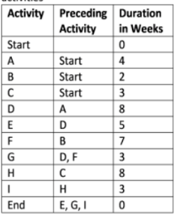
You are requested to do the critical path analysis by providing all the paths (from the start to the end of the project) with duration for each path, the critical path and project duration, the early start value (the first activity has an early start of zero), and the float for each task/activity of the project.
Request 5 (20%): The project was expected to cost $6 million for three months. At the end of one month, you use earned value management as a performance management technique and get the following information:
EV = $2.3 million; PV = $2.8 million; AC = $2.1 million
Calculate and give your comments (current status, forecast and recommended adjustment) on the schedule and cost performance of the project

